* **Task 3: GitHub and Scrumdo**

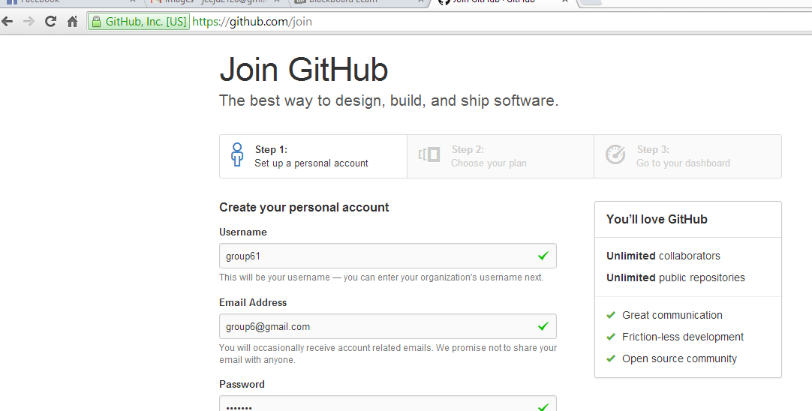

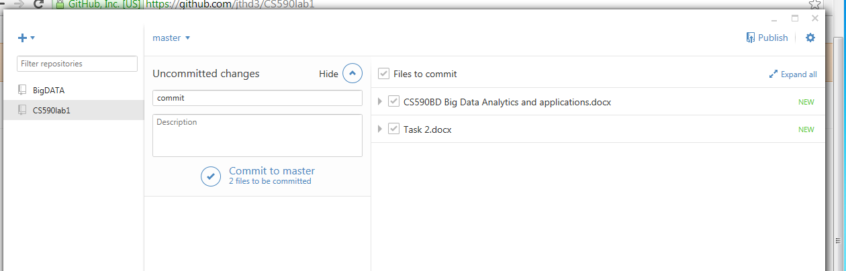

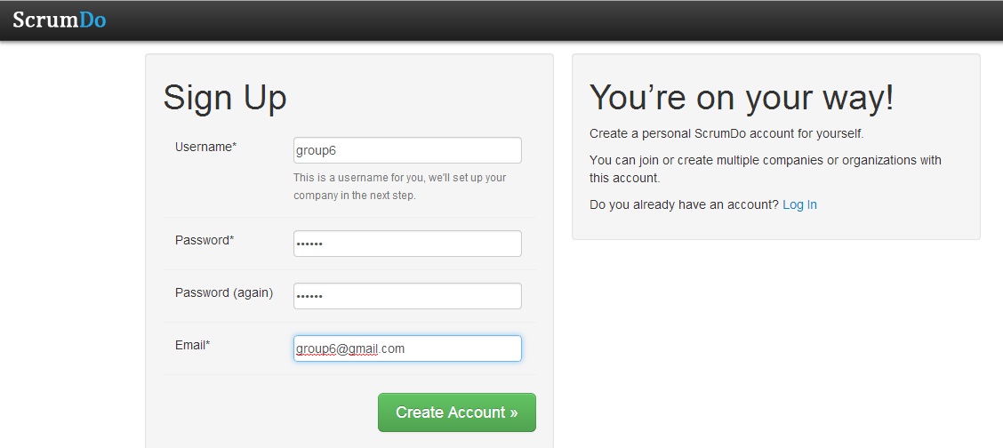

Scrumdo username-jthd3

(created two accounts one for group and one is individual)